1. A 2D game where you are skating around a pixely style neon orange landscape, dodging obstacles and disintegrating bystanders you run into with your laser skateboard. You would ramp off things to do tricks, and could take multiple routes such as in the subway or through a building.

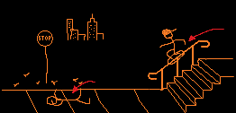

2. A twin stick style game where you control the characters movement with one stick and the environment with the other. It would be 3D isometric dungeon crawler, where one stick would highlight a piece of the environment and move it whilst the other navigates the dungeon. You could enter a room with an enemy and pull the wall off as a physics object, crushing it between 2 walls.

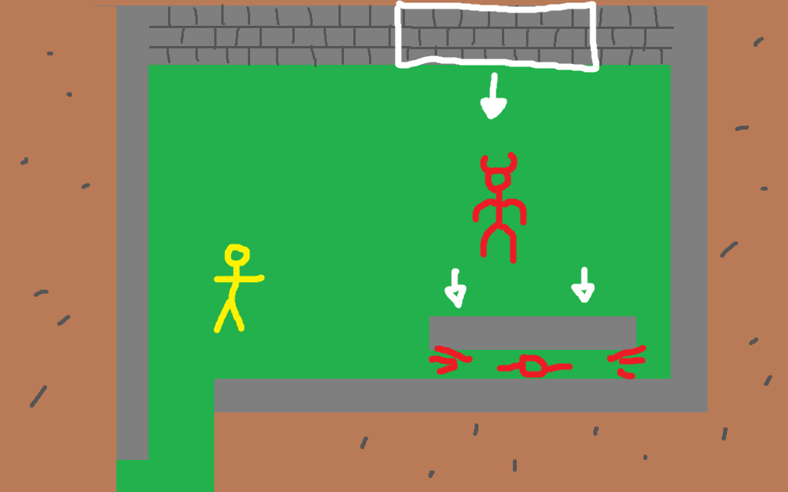

3. A 3D platforming game where you play as a frog. Must traverse the levels by jumping, crawling on walls, and using your tongue to stick and swing from things. Traverse through different levels like jungle, river, city. The tongue swinging would be physics-based and you could throw yourself with momentum.

4. A simple cooking game where it’s a world championship. You pick your country and have a special dish, which would be the national food such as Italy and pizza. You compete in the same kitchen area, so the other team can mess with you and be messed with.

5. A game where there are gravity distortions in an office building and you have to escape. These distortions can’t be seen so you must use the things around you to detect them. The hazards would be varying sizes, and some might push whilst others pull. For example, you could use a coffee that someone left behind and throw it down the corridor to see if the cup or liquid interacts with anything. A box of staples could also be thrown to cover a wider area